HANDS-ON 2

GitIgnore

.gitignore is a plain text file used in Git repositories to specify which files or folders should be ignored by Git.
Ignored files are not tracked, staged, or committed.
It helps keep the repository clean by excluding temporary, build, log, or sensitive files from version control.

Explain how to ignore unwanted files using git ignore

1. Create a file named .gitignore in the root of your Git repository.
2. Add patterns for files/folders you want Git to ignore.
Example:
*.log # Ignore all .log files
log/ # Ignore any folder named log
3. Save the file.
4. If those files were already tracked, remove them from tracking with:
git rm --cached <file/folder>
5. Commit the .gitignore file so it applies to the repository.

Steps
Step 1 – Verify Git Installation
git –version
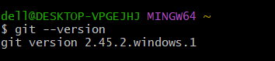

Step 2– Create .log File and log Folder
New-Item -ItemType Directory -Name log
"server log content" | Out-File server.log -Encoding utf8
"debug inside folder" | Out-File .\log\debug.log -Encoding utf8
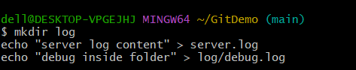

Step 3 – Create .gitignore File
notepad .gitignore
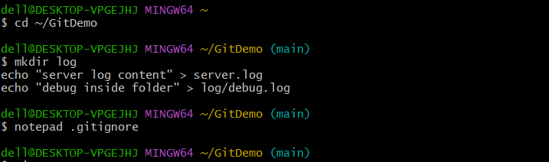

Step 4 – Verify Ignored Files
git status
git check-ignore -v server.log log/debug.log

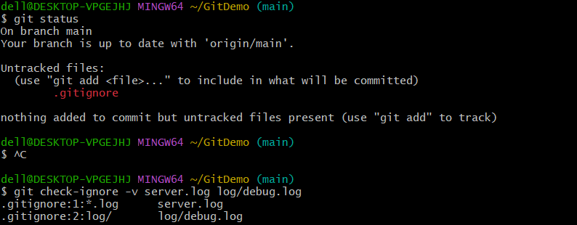

Output--
